**ONLINE MARKET PLACE FOR ORAGNIC FOODS USING BLOCKCHAIN**

Project ID: 19_20-J 06

Project Proposal Report

H.D.M. Perera, D.K.G.S.H. Liyanage, D.S.M. Mallikarachchi, A.W.M.J.S. Bandara

BSc Special (Hons) - Information Technology

(Specialization in Information Technology)

Department of Information Technology

Sri Lanka Institute of Information Technology

Sri Lanka

August, 2019

**ONLINE MARKET PLACE FOR ORAGNIC FOODS USING BLOCKCHAIN**

Project ID: 19_20-J 06

Project Proposal Report

H.D.M. Perera IT16122956

D.K.G.S.H. Liyanage IT16175358

D.S.M. Mallikarachchi IT16235298

A.W.M.J.S. Bandara IT15145994

Supervisor: Dr. Dharshana Kasthurirathna

BSc Special (Hons) - Information Technology

(Specialization in Information Technology)

Department of Information Technology

Sri Lanka Institute of Information Technology

Sri Lanka

Table of Contents

DECLARATION 4

ABSTRACT 5

LIST OF FIGURES 6

LIST OF TABLES 6

1 INTRODUCTION 7

1.1 Background 7

1.2 Literature Review 8

1.3 Research Problem 11

1.4 Research Gap 13

2 OBJECTIVES 14

1.1 Main Objectives 14

1.2 Specific Objectives 14

3 METHODOLOGY 16

4 DESCRIPTION OF PERSONAL AND FACILITIES 19

5 TIME PLAN 21

6 REFERENCES 23

7 APPENDIXES 24

# DECLARATION

We declare that this is our own work and this project proposal does not incorporate without acknowledgement any material previously submitted for a Degree or Diploma in any other University or institute of higher learning and to the best of our knowledge and belief it does not contain any material previously published or written by another person except where the acknowledgement is made in the text.

|  |  |
| --- | --- |
| ------------------------------------ | ------------------------------------ |
| H.D.M. Perera | D.K.G.S.H. Liyanage |
| IT16122956 | IT16175358 |
| -------------------------------------- | ------------------------------------ |
| D.S.M. Mallikarachchi | A.W.M.J.S. Bandara |
| IT16235298 | IT15145994 |

The above candidates are carrying out research for the undergraduate dissertation under my supervision.

|  |  |
| --- | --- |
| ……………………………… | ……………………………… |
| Dr. Dharshana Kasthurirathna | Date |

# ABSTRACT

The life cycle of a product is a fascinating one. The next time you’re buying something in the supermarket, think of what all it went through to get in your hands. Think about where all the raw materials came from, who all transported the raw material to production plant where it was created, and how it eventually got packaged and ended up in the very shop where you are buying it right now.

At present, most people tend to choose organic food either voluntarily or involuntarily. However, there is no clear way for the customers to identify organic foods in the existing market. This has led to deterioration of the health and lifestyle of customers. Therefore, as a solution, it is proposed to introduce a mobile application to identify fresh and organic foods distinctly from other products.

The main objective is to give the customers an opportunity to find fresh, organic products with ease by ensuring that all steps from food production to delivering it to the customer are transparent and reliable. At the same time, we wish to analyze the amount of sales at a given time frame and within the next quarter.

# LIST OF FIGURES

Figure 1:U.S. Organic Food vs Total Food Sales, Growth and Penetration 11

Figure 2:Blockchain Process Diagram 16

Figure 3:Proposed Fake Reviews Detection Architecture 17

Figure 4:Propsed Sentiment Analysis Architecture 18

Figure 5:Time Allocation of the Whole Project 21

Figure 6:Gantt Chart based on Time Allocation 22

Figure 7:Work Breakdown Structure 24

# LIST OF TABLES

Table 1:Comparison Table 13

Table 2:Personal and Facilities Allocation 19

# INTRODUCTION

## Background

One of the main reasons to lack efficiency in traditional food supply chain is existence of many intermediaries between the farmers and food processing companies/Supermarket and again between food processing companies and the consumers, which result in greater complexity and lower efficiency in food supply chain. Lack of mutuality and cooperation between the members involved in food supply chain is also the one of the main reasons behind the inefficiency in supply chain management. The supply chain is still unable to trace the source of illegal activities such as fake commodities, illegal labor and money laundering. A proper supply chain management requires better understanding and co-operation among its members from upward stream to downward stream such that problems relating to supply and demand could be minimized. Other problem that Sri Lankan consumers faced today is the inability to properly identify food products that are unsuitable for human consumption. The health of consumers declines as a result of consuming such food products. They have no system to identify or verify chemical compounds, no of changed hands or any other ingredients in food products. Thus, at present consumers tend to deviate away from supermarket and other groceries towards more convenient food sources or choose wisely with knowledge of chemical compounds spending their valuable time and money

Traditional Databases are one of long term technique that has been used for recognizing and storing all related data in supply chain management. However, there are many drawbacks such as supply chain transparency, security and fraud controlling and there is no mechanism to find out and insure the security and transparency of supply chain. If the above problems could be solved using any new technology, it could be easy to find out which product have more quality within the market

So as a solution we proposed an organic food detection web application which include block chain technology to store all related steps throughout the food supply chain and also an analysis of product review to identify and detect which comments are fake or not. Using the output of this analysis a sentiment analysis will be performed. Finally, when customer order a product based on some constraints like time, destination, cost the application will show an optimal path to deliver the product to the customer.

## Literature Review

We performed literature review on existing applications, studies and researches with similar approaches before the proposal of our research project. Some of the prominent and noted researches are reviewed below.

**Halal Traceability and Halal Tracking Systems in Strengthening Halal Food Supply Chain for Food Industry in Malaysia** [1]

This research is based on Halal Food Tracking System which discuss on some approaches towards halal food traceability and tracking currently used in Malaysia. The Halal industry involves all farm-to-table operations. This system functions as a tool for communication making information available along the supply chain and which provides a set of data about location of food and food ingredients along the production chain. In this, Tracing is aimed to finding the history of a product. Halal traceability system can be used to increase Halal Transparency in the Production chain. Traceability system Runs with various Requirements complete of Radio Frequency Identification (RFID). RFID covers from the high-end business sectors to mid-range usage due to RFID’s feasibility in the number of applications available today. The main drawback of this research is believing that more global applications and database is needed in order to provide more information about all halal food products available in the market. Secondly is the lack of security due to use of same copies of Halal logo and making changes in the production change to which will lead to deceiving the consumers. So, to keep up the security and transparency in supply chain we have to optimize the application to keep the supply chain details unchangeable and undeletable (Using Block Chain Technology).

**Blockchain based Wine Supply Chain Traceability System** [2]

This study proposes a blockchain based wine supply chain traceability system where every transaction is recorded as a block in the chain and is visible to the relevant participants. These blocks of information are immutable since any change to the recorded information will break the chain. In addition to providing quality information management framework, the proposed traceability system enables transparency, safety, and security in the overall process from the grape to the bottle. However, for simplicity, current implementation only deals with public data. Limitation is that the current system only provides limited command-line based instructions to store information in the chain. (No graphical user interface (GUI) and no application programming interface (API) to easily store and retrieve information in the chain)

**An optimization approach for communal home meal delivery service** [3]

This research considers the communal home meal delivery problem. The issue can be setup as a multiple transporting salesman problem with time windows. And it is closed to the well-studied vehicle routing problem with time windows. Its objective is to find the optimal routes for distributing various shipments, such as goods, mail and raw materials. The calculation tests were done with an AMD Athlon X2 3800+ computer with 1 GB memory. In the current routing plan, the average distance of the current, manually planned tours is 26.21 km. correspondingly, the shortest and longest current routes are 9 and 45 km. To be more precise, the current planning is based on a manual geographic partitioning of the city.

**Integration of GIS, GPS, and optimization technologies for the effective control of parcel delivery service** [4]

An intelligent monitoring and control system for parcel delivery service is described in this section. To manage pickup and delivery operations more effectively. Geographical information system (GIS), global positioning system (GPS), and wireless communication technologies are applied to the system which consists of three subsystems, pick-up and delivery sequence planning system, pick-up and delivery monitoring system, and PDA execution system. Address information should be corrected at the receipt stage of pick-up requests utilizing the address management system. Also, it is necessary to devise more elaborate mechanisms for the real-time reservation to handle new pick-up requests effectively. Those mechanisms may use information on vehicles positions and remaining pick-ups to balance workloads among postmen and meet customers’ request times. One of the major technologies used in our system is pick-up and delivery sequence planning technology. This problem is to create pick-up and delivery sequence and time schedule with the several input/ output parameters and constraints. The drivers pick up the meals according to a fixed schedule, starting from 10.30 in the morning. Packing the meals takes about 10 min, and only one vehicle can be loaded at a time. Therefore, loading time windows are specified for each of the nine vehicles. As a result, the last vehicle departs from the kitchen at around 10 o’clock. After packing, the cars deliver the meals according to routes specified by the city of Jyvaskyla. All deliveries have to be made between 10.00 and 13.30, namely within 3.5 h. However, the Finnish Food Safety Authority (EVIRA) recommends that warm meals should be delivered within two hours of leaving the kitchen. In practice, the latter time limit is often exceeded, as it is not an official fixed time limit that has to be respected.

**Sentiment Analysis for Product Review** [5]

Main idea of this research paper was to analyzes the user reviews, emotions and labels the ‘better’ and ‘worse’ sentiment as positive and negative respectively. The main objective was to identifying polarity of the data in the web and classifying them. This paper is much relevant to the research we conduct due to the sentiment analysis approaches they followed. This paper presents the theoretical analysis of some well-known methods or proposal of Sentiment Analysis. In this paper following combinations are taken into for analysis, adverbs-adjectives, adverbs-verbs, adjectives-verbs and adverbs-adjectives-verbs along with adverbs, adjectives and verbs. The Standard classifier like Naive Bayes (NB), Linear Model and Decision Tree are used to deduct result and for analysis. But as drawbacks of this research, emoji’s, score ratings according to comments has not been considered. In our system we intend to consider aspects like price, quality, delivery service of comments and provide scores product wise respectively.

**A knowledge extraction system from online reviews using fuzzy logic** [6]

The research paper aims to design and development of an automatic knowledge extraction system from online hotel reviews of tourists. The system focuses on a semantic analysis from hotel reviews using the ontology. As a knowledge base hotel information extraction and storing and using the parser to solve the systematic analysis problems. As well as, system proposed logic-based method for calculate tourist satisfaction level considering hotel services and facilities also. Method gives good accuracy, precision and recall rates. Knowledge extraction system of online tourist reviews in English language by extracting hotel information from reviews as hotel features and calculating tourist satisfaction levels on each hotel feature. Parser engine act as a core process for finding significant keywords used in semantic analysis. Overall scores are calculated by using fuzzy logic and use rating system for reviews. The research performs a clear and easy understandable reviews summarized by visualizing the result in tree structure and that result can be used to explore a best hotel in details. But the problem of the proposed system is its incapable of handling the ambiguity present in modern English grammar rules such as idioms, similes, etc.

**Adequate assessment of the customer's actual reviews through comparing them with the fake ones** [7]

The system proposed the ontology model of hotel services and it describes aspects and categories of services and their relationships. In addition, the representation of the ontology models allows translating the model into an RDF schema, which will use for generating reference fake reviews. In the system information extraction for building ontologies covering on extensive range of applications drawn from corpora. To evaluate the level of hotels and their facilities, a considerable number of online booking system were analyzed with tripadvisior.com being established as the prominent source. The representation of the ontology allows translating the model into RDF schema which will use for generating reference fake review. System used three methods for generation fake reviews. First is from adjectives knowledge database by sentences ontology. Ex 6 simple sentences where the attribute is port of sentence. Second and third methods based on ontology with simple or extended evaluation. The evaluation present in the concerned reference journal article uses 3 knowledge bases: developed manually to return and accurate result. This however effective, reduces efficiency and increases required efferot.in General, effort to result ratio is unfavorable.

## Research Problem

In a society moving towards health-conscious living and product purchasing, the organic food supply sector currently holds a revered position in the global food industry. According to the statistics of global food consumption for the past decade, the demand for organic produce has been continuously increasing as displayed by the figure below.

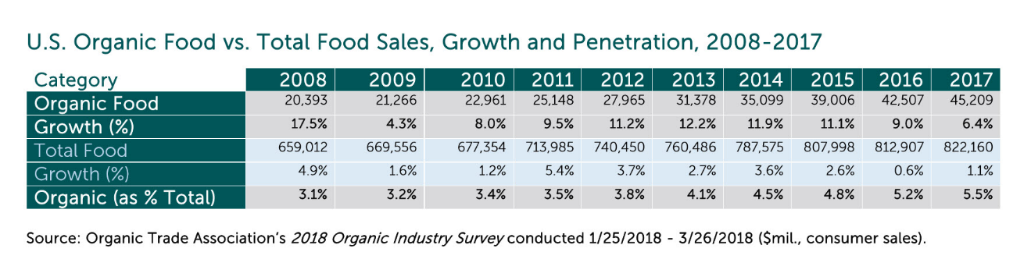

Figure :U.S. Organic Food vs Total Food Sales, Growth and Penetration

While the global consumption of organic produce seems to increase as a total percentage, it is important to facilitate the target demographic in Sri Lanka as intended by this research in particular since the infrastructure to aid such a purpose appears to be somewhat lacking. Currently in Sri Lanka, the organic food industry has not attained the global pivotal place which it holds. However, upon recent multiple influences the general local consumer does not seem to be satisfied in generalized food product consumption. Therefore, this research mainly focuses on delivering a full-fledged "online market for organic food", with the intention of satisfying the target demographic identified as well as appealing to potential consumers.

The research intentions could be broken down to three primitive constructive blocks as mentioned.

* A fully monitored tracking procedure for the entire process from purchase to delivery of the product in concern by utilizing blockchain technology.
* A complete delivery system with highly optimized navigation with relevance to multiple constraints.
* A product review system utilizing semantic analysis and ontologies for filtrations and rating purposes.

Since the main concern of the research is to enhance the organic food consumption experience amongst the local health conscious consumer, the proposed system would consist of a highly informative farm to table approach. The buyer in concern would be able to visit the respective website on which all the products are to be obtained from. On the website, each product would contain information deemed important for the potential customer with due prominence given to express product quality and freshness. Furthermore, once a purchase has been made, upon delivery, the customer will receive information regarding said products. To enhance the authenticity of the details that appeal to the potential customer, every bit of it is enlisted in a blockchain. This ensures that information tampering does not occur and exterminate the possibility of fraudulent actions.

For a food related service to be successful, it is crucial to have a well-organized delivery system. For the proposed system, the delivery service component would focus on continuously discovering optimum routing/ navigation pertaining to the constraints of time, distance and cost etc. This would ensure that the produce requested by a customer reaches its destination with no harm inflicted on product quality overall service integrity.

Upon product retrieval, a customer would be able to give an objective review on the service and the purchase. These reviews and comments would be analyzed through a semantic approach utilizing an ontology model based on parameterized keywords and the sentiment behind each review would be scored through a specialized rating system which would enable the system to ultimately improve product and service quality moving forward.

## Research Gap

As discussed above, though many of the current systems and researches have individual components of our proposed system, they do not yet been able to deliver a complete Market place which collectively consisting of all the features we suggested.

Table :Comparison Table

|  |  |  |  |  |  |  |  |
| --- | --- | --- | --- | --- | --- | --- | --- |
| Feature | Proposed System | Halal Traceability and Halal Tracking Systems | Wine Supply Chain Traceability System | An optimization approach for communal home meal delivery service | Integration of GIS, GPS, and optimization technologies | Sentiment Analysis for Product Review | A knowledge extraction system from online reviews using fuzzy logic |
| Blockchain Technology |  |  |  |  |  |  |  |
| User-Friendly GUI |  |  |  |  |  |  |  |
| Security |  |  |  |  |  |  |  |
| Profitability |  |  |  |  |  |  |  |
| Product Review Accuracy |  |  |  |  |  |  |  |
| Real-Time Traffic Monitoring |  |  |  |  |  |  |  |
| Fake Comments detection |  |  |  |  |  |  |  |

# OBJECTIVES

## Main Objectives

**Introduce an Online Market Platform for Organic Foods**: Introducing an Online Market Platform which give the customers an opportunity to find fresh, organic products with ease by ensuring that all steps from food production to delivering it to the customer are transparent and reliable. When literature reviewing we found some similar projects but not a whole one platform for Organic Foods. So, we thought of this kind of research. We expect to accomplish this in higher accuracy and quality.

**Providing Transparency and Optimizing the Route Delay when Delivering Products:** When Purchasing products customer have no idea about how the product comes to their hands. This is one of main drawback when purchasing goods from the market. So, one of our main aim is to provide transparency in supply chain for the customers. Other downside is time taken to deliver the product. Through our research other objective is to reduce and optimize the route delay when delivering Products to the customer. We assume that this would help for the customers, retailers, distributors together with the public community from various ways, in saving money, time and finding fresh foods within the market.

## Specific Objectives

**Blockchain Technology**

A blockchain will be used as an intermediate database to track all steps to assist in the process of supply products

**User-Friendly GUI**

All stakeholders invested in the system are capable of accessing a user-friendly GUI to interact with every facet of the system.

**Transparency**

Identify all steps from food production to delivering it to the customer are transparent and reliable through block chain technology. This will be useful for consumers to make proper decisions when purchasing products through our platform.

**Security**

Security will be automatically increased hence data is stored in blocks so no one update or delete any hash value in the Block chain.

**Profitability**

Although the capabilities of the system in reference has great potential, the entire enterprise depends on a single pillar when it comes to automated routing. The system in concern utilizes a commercial software; SPIDER Designer 4.0 from an authorized vendor, and this reduces the dependability in connection with its users. The proposed system in the research plans to eradicate this potential unfavorable outcome by introducing a native routing tool/ process to drastically reduce costs and dependencies (both systematically and commercially) while considerably increasing income and overall system worth.

**Real-Time Traffic Monitoring**

Delivery systems in general depend on multiple factors when assessing their performance. The referenced research is only capable of utilizing GPS for its navigation purposes and this although sufficient, does not account to withstand all possible constraints of a given delivery trip. The proposed research solution intends to include real time traffic analysis methods to be included in the final system, thus decreasing running costs (fuel etc.) while increasing efficiency as well as overall customer satisfaction owing to the quality (of the product) retained at the delivery end point.

**Product Review Accuracy**

Currently however, the rating systems generated by utilizing comments/ reviews exist only in a very narrow spectrum depicted by the words “negative”, “neutral”, and” positive”. This research focuses on delivering ratings by using a scoring model which spans (for example) across 1-10 in a mathematical/ quantitative solution. This would increase the accuracy vastly and would aid in long term developments as far as the system is concerned.

# METHODOLOGY

This section carries out our research methodologies how we are going to carry out our research works to build a web application for Organic Foods. In order to conduct our research, we needed some set of procedures. Because our research is based on **Blockchain Technology.**

Traditional food supply chain is existence of many intermediaries between the farmers and food processing companies/Supermarket. However, due this lots of intermediates the supply chain is unable to trace the source of illegal activities such as fake commodities, illegal labor and money laundering. The system that we propose as a solution to this problem can be used to purchase products orders according to their preferences while looking to the supply chain of related products. Again, Customer can comment on the Product by looking on the supply chain and according to those comments, system provide a review on those comments by using “Sentiment Analysis”. This system is more effective in the process of buying Fresh foods from the market.

**Storing Supply Chain Details using Blockchain**

Main functionality in this segment would be focused around the process of acquiring and delivering/ distributing goods. Initially as soon as the produce is obtained from the farmers, the blockchain process begins in storing details relevant to the product. Once the produce is obtained, pertaining to the needs, respective manufacturers would receive the ingredients/ material. Important dates and details would further be appended to the blockchain and be received by the suppliers. From suppliers, the products manufactured would be distributed across all supply channels with retailers handling the end node of the blockchain process till customers interact with advertised products. The blockchain would further act as the unchangeable data storage for each product throughout its entire lifecycle in this business logic.

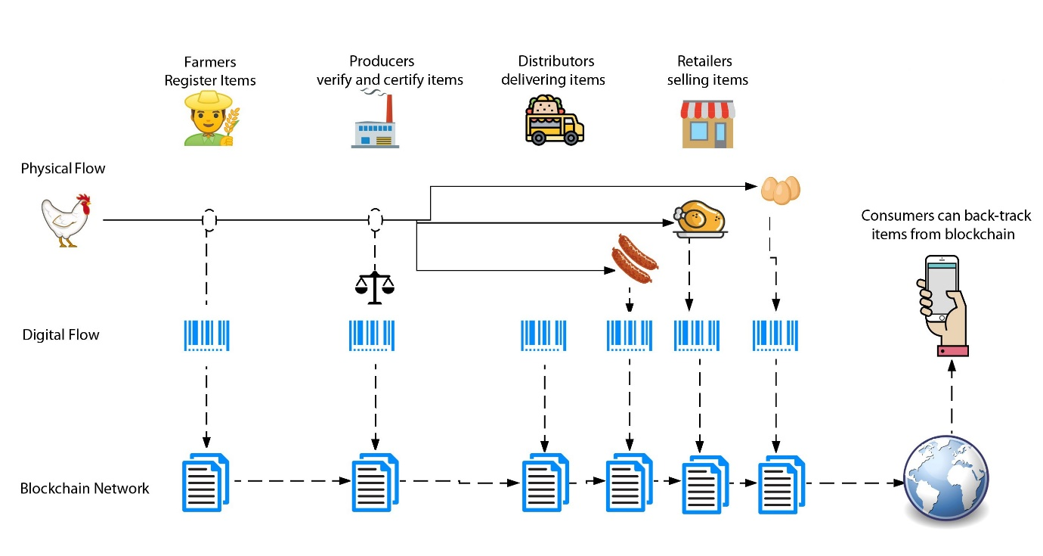

Figure :Blockchain Process Diagram

**Choose the Optimal Path for Delivery**

Once orders have been placed, to ensure minimal deterioration of quality occurs, the most efficient and optimal path has to be detected by the delivery navigation process. This would refer to many constraints such as time, distance, fuel costs etc. in determining the best route possible to reach a customer as quickly as possible using a continuous variable adaptive real time navigation process which takes not only geographical features but also traffic and road conditions etc. into account as well.

**Analysis of Product Reviews to Detect fake and Spam Reviews**

While the blockchain process listed above ensures data security and authenticity throughout the entire systematic online marketing approach, the consumers and general users are capable of submitting objective reviews in forms of comments as feedback to improve the system capabilities and handle malfunctions. This poses a potential risk in accumulating and accounting up for spam and fake reviews from sabotage oriented competitive strategies as well as general customers. To analyze the authenticity customer catalogs would have to be accessed and compared against comment users of suspect reviews. Detecting these spam and fake comments would ensure that the review related product rating stays relevant and accurate.

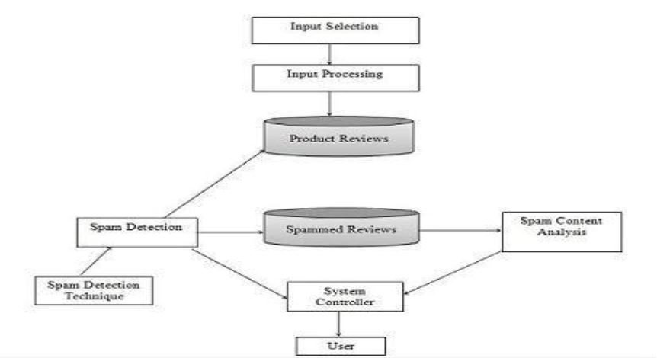

Figure :Proposed Fake Reviews Detection Architecture

**Sentiment Analysis using Reviewed Comments**

Using the ontology model proposed, the content of user reviews would be filtered according to respective domains required by the standards of final rating required for a particular product. This requires product review comments to be dissected utilizing semantic analysis-based approaches while providing a rating spectrum as expressed previously in the literature study.

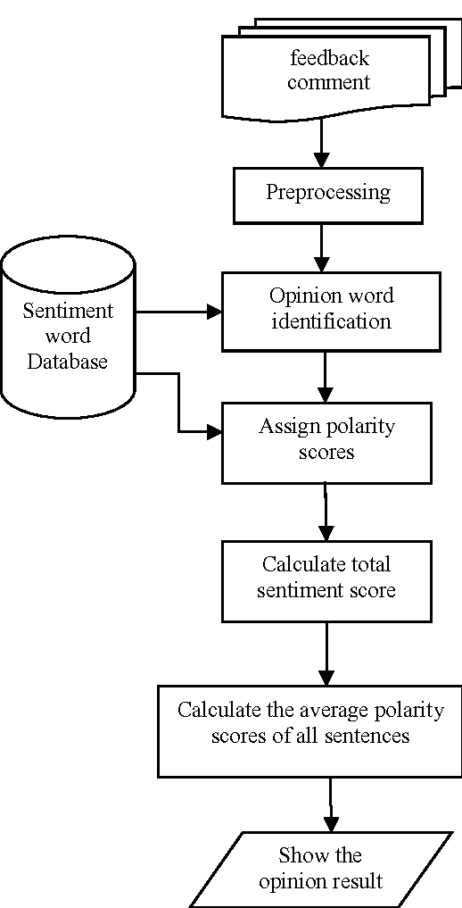

Figure :Propsed Sentiment Analysis Architecture

# DESCRIPTION OF PERSONAL AND FACILITIES

Table :Personal and Facilities Allocation

|  |  |  |
| --- | --- | --- |
| **Member** | **Research Component** | **Tasks** |
| IT16122956  H.D.M. Perera | Custom blockchain for Food Supply chain Storage | * Implementation of a blockchain which helps the process of storing all steps from food production to delivering it to the customer. * The blockchain would also function as an immutable ledger, such that that it would contain the entire history of the Product. * Purpose of this process is to Provide reliability and integrity in the supply chain for the Consumer and also the use of blockchain in supply chain management will work as a game changer by eliminating the vulnerabilities and inefficiencies of the current supply chain systems. |
| IT16235298  D.S.M. Mallikarachchi | Technique to find the Optimal Delivery Path | * Implement a technique which can find the best way to deliver the products. * That technique concerns the time, how long you should go to the destination and the cost like constants to calculate the efficiency of the way. * And finally, it displays the optimize way by using a map. |
| IT15145994  A.W.M.J.S. Bandara | Sentiment Analysis for Product Reviews | * In order to identify the polarity of user experiences those growing row data are an extremely high source of information for any decision-making process either positive or negative. * So, sentiment analysis approach is going to be used in order to analysis of such huge data in our system automatically. * The main aim of using sentiment analysis approach in our system is to identifying the polarity of the data in our system and classifying them. |
| IT16175358  D.K.G.S.H. Liyanage | Identify and Detect the accuracy of Reviews Provided by the Consumers | * This would be achieved by incorporating an ontology model where the text data within reviews would be extracted to be compared against keywords categorized under "good/ favorable" and "bad/ unfavorable". These reviews then would be utilized in rating the product in concern according to the calculated severity of the positives and negatives. * Furthermore, to alleviate the system from succumbing to inaccurate reviews/ fraudulent comments, an automatic detection would also be developed to identify and separate genuine comments submitted by actual users from deliberate sabotage efforts while giving due prominence for genuine customer care and retaining business authenticity. |

# TIME PLAN

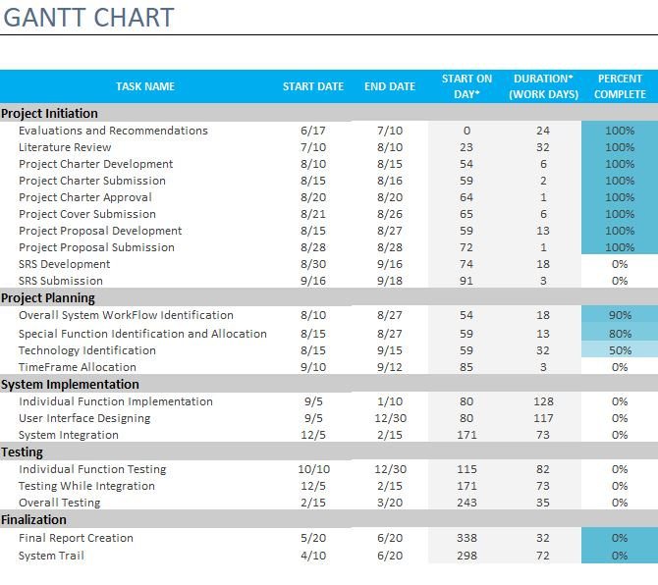

Figure :Time Allocation of the Whole Project

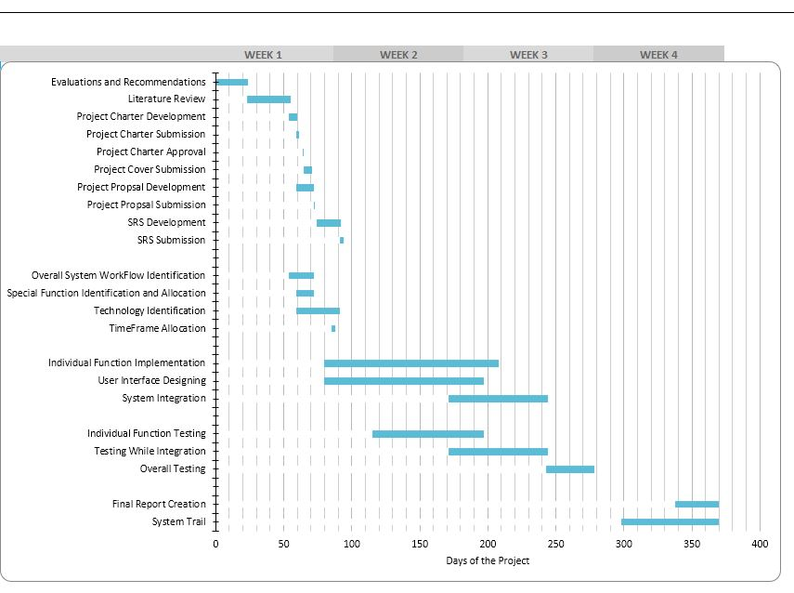

Figure :Gantt Chart based on Time Allocation

# REFERENCES

|  |  |
| --- | --- |
| [1] | S. Zailani, Z. Arrifin, N. A. Wahid, R. Othman and Y. Fernando, "Halal Traceability and Halal Tracking Systems in Strengthening Halal Food Supply Chain for Food Industry in Malaysia (A Review)," *Journal of Food Technology,* vol. 8, no. 3, pp. 74-81, 2010. |
| [2] | K. Biswas, V. Muthukkumarasamy and W. L. Tan, "Blockchain based Wine Supply Chain Traceability," 2017. |
| [3] | O. Bräysy, P. Nakari and W. Dullaert, "An optimization approach for communal home meal delivery service: A case study," *Journal of Computational and Applied Mathematics,* vol. 232, no. 1, pp. 46-53, 2009. |
| [4] | H. Jung, K. Lee and W. Chun, "Integration of GIS, GPS, and optimization technologies for the effective control of parcel delivery service," *Computers & Industrial Engineering,* vol. 51, no. 1, pp. 154-162, 2006. |
| [5] | N. Sultan, P. Kumar, M. R. Patra, S. Chandra and S. Alam, "Sentiment Analysis For Product Review," *International Journal of Soft Computing,* vol. 9, 2019. |
| [6] | P. Kitwatthanathawon, T. Angskun and J. Angskun, "A knowledge extraction system from online reviews using fuzzy logic," *2012 Ninth International Conference on Computer Science and Software Engineering (JCSSE),* 2012. |
| [7] | G. Bekmanova, A. Sharipbay, A. Omarbekova, G. Yelibayeva and B. Yergesh, "Adequate assessment of the customers actual reviews through comparing them with the fake ones," *2017 International Conference on Engineering and Technology (ICET),* 2017. |

# APPENDIXES

Figure :Work Breakdown Structure